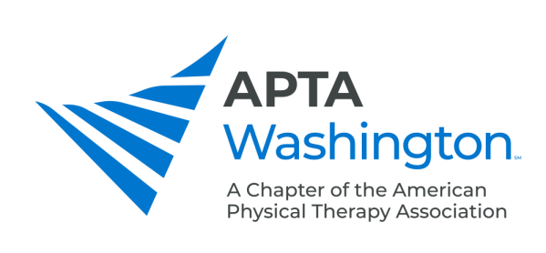

Spinal Manipulation FAQs
Updated December 20, 2022

Disclaimer: This is an advisory document only and doesn’t imply or guarantee approval for the spinal manipulation endorsement granted by the Washington State Secretary of Health. Individual physical therapists are solely responsible for ensuring the accuracy and evidence of adequate training to gain this endorsement.

What counts toward my spinal imaging education?
"spinal diagnostic imaging of no less than 150 hours as outlined in a course curriculum."

Who can perform intramuscular needling (aka dry needling)?
A physical therapist with an intramuscular needling endorsement from the Department of Health (DOH) may perform intramuscular needling.

Since I qualify to be a clinical supervisor, may I be my own clinical supervisor?
No

Do I need to have the spinal manipulation endorsement to be a clinical supervisor? No. Please see the document Spinal Manipulation Clinical Supervisor - Who Qualifies on the Spinal Manipulation Endorsement Resources page.

What if my clinical supervisor has died?
You may get someone else from the organization that your clinical supervisor represented to sign the form and attest that you were clinically supervised by that person.

What's necessary for clinical supervision?
- You must complete 150 hours with the supervisor in the room, personally diagnosing the condition to be treated and authorizing the procedures to be performed.

- You must receive direct supervision for an additional 150 hours, where the supervisor is on the premises.

- Current qualified supervisors: a licensed chiropractor, a licensed osteopathic physician, those PTs holding a valid spinal manipulation endorsement on their Washington PT license.

Can a patient case presentation hours count in the supervision hours?
No, the law is very specific about this. Please see the Q and A for what’s necessary for clinical supervision above.

Can my practical spinal manipulation coursework count towards the supervision hours?
No. The supervision hours must occur in clinical situations outside of the classroom setting.

Is there a timeline for completion of the educational and supervision requirements?
If all of the didactic and practical training requirements are completed, the PT must finish the supervised clinical 300 hours by January 1, 2017.
There is no time limit for completion of the didactic requirements. One may start and complete the 500 education hours at any point.
Hours may overlap between didactic and practical training requirements.

Where do I sign my application?
The applicant for endorsement does not have a spot for the applicant to sign their application. At the top of the applicant on the line where you enter your name, we recommend you also include your signature too.

What does my clinical supervisor have to complete on my application?
The supervisor must sign the application, as well as write in the date and location of the hours provides.

What if I’ve been clinically supervised for a lot more hours than 300?
We recommend that you obtain signatures from the clinical supervisors who are easiest to reach until you have the required 300 hours covered. Sending in more information than that is not necessary.

Should I send proof of education and training in with my application for the endorsement?
No. You would only need to provide this proof if your endorsement is challenged.

Where should I send my application?
To the DOH address included on the application.

Do I need to apply every time I renew my license?
No. But you will need to take 10 hours of continuing education related to the practice of spinal manipulation during every two-year continuing education reporting period in order to keep the endorsement.

